**Ideation Phase**

**Define the Problem Statements**

|  |  |
| --- | --- |
| Date | 19 September 2022 |
| Team ID | PNT2022TMID08592 |
| Project Name | Real-Time Communication System Powered by AI for Specially Abled |
| Maximum Marks | 2 Marks |

**Customer Problem Statement:**

In our society, we have people with disabilities. The technology is developing day by day but no significant developments are undertaken for the betterment of these people. Communications between deaf-mute and a normal person has always been a challenging task. It is very difficult for mute people to convey their message to normal people. Since normal people are not trained on hand sign language. In emergency times conveying their message is very difficult. The human hand has remained a popular choice to convey information in situations where other forms like speech cannot be used. Voice Conversion System with Hand Gesture Recognition and translation will be very useful to have a proper conversation between a normal person and an impaired person in any language.

**Example:**

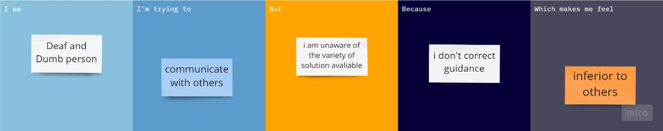

|  |  |  |  |  |  |
| --- | --- | --- | --- | --- | --- |
| **Problem**  **Statement (PS)** | **I am**  **(Customer)** | **I’m trying to** | **But** | **Because** | **Which makes me feel** |
| PS-1 | Deaf Person | Communicate with others | I am unaware of the variety of solution available | I do not have correct guidance | Inferior to others |
| PS-2 | Deaf and Dump Person | Convey my thoughts but peoples can’t my language | I am unaware about the technology development | I am unable to know the current updates | Stressed |